Program: 2024 Summer Bridge Experience
From: Health Services
Re: Instructions for Health Services Onboarding Page in the Student Portal

Health Services is using an electronic medical record in our practice. Students will need to “on-board” with required paperwork through the onpatient portal of our electronic record. You will receive an email in your Landmark.edu account like the one below directing you to sign up in the Health Services onpatient portal. This particular portal is different from the onboarding portal used by other divisions on campus.
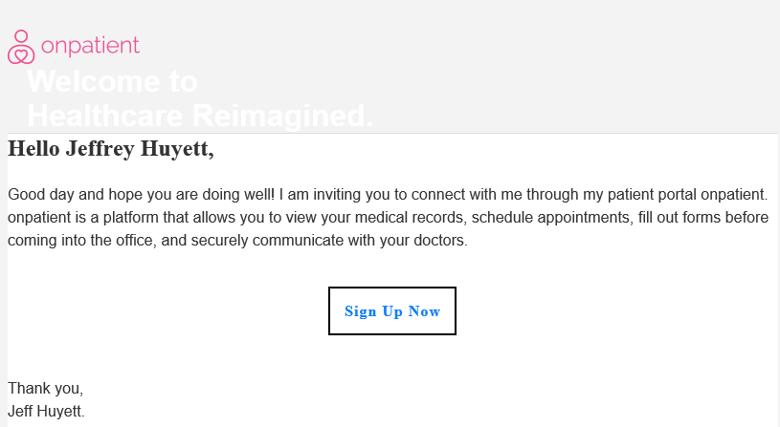
You can navigate onpatient on your desktop or laptop, or you can download the app to your phone via Google or Apple app stores.

Choose a password that you will remember and keep that password documented with your other passwords in a place of your choosing like your smartphone.
Once you open onpatient, you will see a placeholder appointment booked for you in order to complete the forms. Hit the “Check In” button connected to that appointment and complete the form shown. Complete this form with as much information as you can convey about your particular health history, emergency contacts, and allergy information. Part of the form includes your vaccination history to document the Vermont state-required vaccinations for congregate living situations. You MUST have completed the Health History, tuberculosis screen and vaccination records to enter campus. You will need to affirm the Consent Forms listed on the appointment check-in.
Once you have completed the pre-made form, you should open the Messages tab if you require a tuberculosis screen outlined in another tab on this portal.
- For Recipient use the pulldown menu and select Jeffrey Huyett.
- Under Subject list your name
- Upload a note documenting a tuberculosis screen from your medical provider.
- Hit Send Message

Health Services staff is available to assist you with any questions or concerns about completing your on- boarding with our office. We can be reached at HealthServices@landmark.edu or by calling 802-387-1636
Please contact us if you need any assistance. Health Services staff are Cindy Brown, Office Manager, Dawn Prouty, RNC, Student Health Nurse, and Jeff Huyett, APRN, BC, Director.

